Day 3: Configuring Basic Network Hardware Theory

Task 1 :- Log in to your home Wi-Fi router's admin panel using its default IP address (usually 192.168.0.1 or 192.168.1.1) and take a screenshot of the login page.

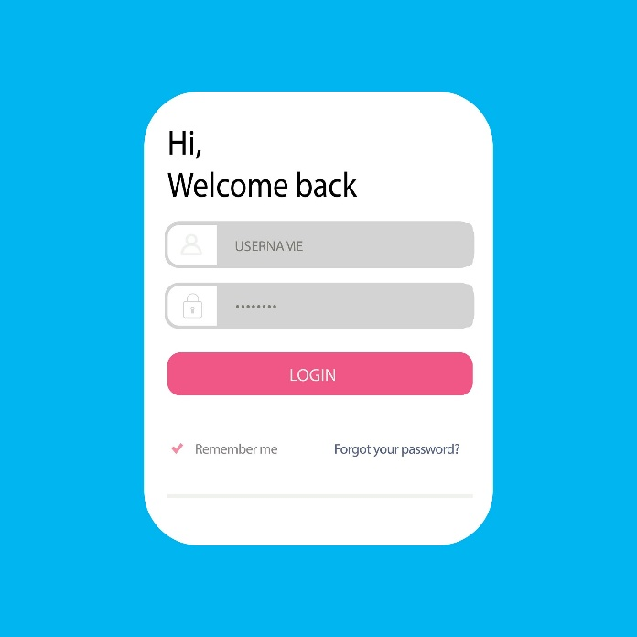

Task 2 :- Find and note down the current IP address, subnet mask, and default gateway assigned to your laptop or mobile device when connected to your Wi-Fi network.

ANS :-
Connection-specific DNS Suffix . :
IPv4 Address. . . . . . . . . . . : 10.86.106.47

IPv6 Address. . . . . . . . . . . : 2409:40c1:4103:fca8:e5a4:e275:93a8:da65

Subnet Mask . . . . . . . . . . . : 255.255.255.0

Default Gateway . . . . . . . . . : fe80::1c3a:5cff:fea7:37a8%2
10.86.106.3

*Here is Practical Screenshot:-

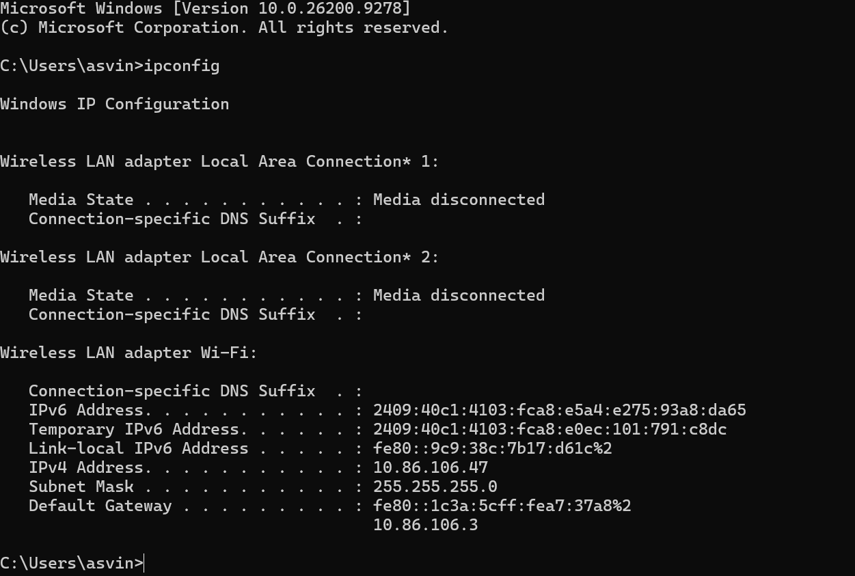
Task 3 :- Change your device's IP address from 'Obtain IP automatically' (DHCP) to a static IP in the same range as your router (for example, set it to 192.168.1.50 if your router is 192.168.1.1), and test if you still have internet access.
ANS:-
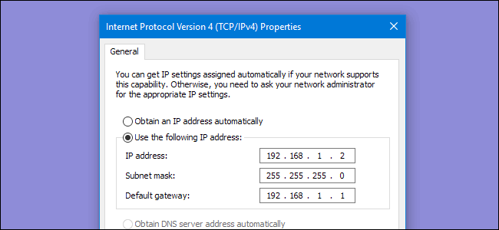

Configure Static IP:

- Open Control Panel > Network and Sharing Center > Change adapter settings.

- Right-click network adapter and select Properties, then double-click Internet Protocol Version 4 (TCP/IPv4).

- Select Use the following IP address and fill in:

  - IP address: 192.168.1.50
  - Subnet mask: 255.255.255.0
  - Default gateway: 192.168.1.1
  - Preferred DNS server: 8.8.8.8 (or your gateway IP)
Test Internet Access :

Open a browser page or run ping 8.8.8.8 in Command Prompt.

Revert to DHCP :

Re-open the same IPv4 properties window, select Obtain an IP address automatically and Obtain DNS server address automatically, then click OK.

Task 4 :- In your router's admin panel, locate the section where you can view or change the DHCP range. Write down the current range, and explain in 2-3 lines what would happen if two devices are assigned the same IP address in this range.

ANS :-

What would Happen If Two Devices assigned the Same IP Address? :-
When two devices share same IP address, an IP address conflict occurs. As a result, both devices will lose their internet connection or experience frequent network drops because the router doesn't know where to send the data.

